Tutorial 2.2: Linting

What is Lint?
In computer programming, lint or lint-like tools perform static source code analysis, checking for symantec discrepancies.
“Linting” means running a basic quality tool against your code. The tool will check your code syntax and provide instructions on how to clean it. Basically, it helps you to write better code and prevent bad formatting, incorrect styling, etc.

Linting Tools
There are many linting tools and we will be using flake8 and pylint in this tutorial.

Flake8
Flake8 is a Python library that wraps PyFlakes, pycodestyle and Ned Batchelder’s McCabe script. It is a great toolkit for checking your code base against coding style (PEP8). It checks only for logical errors in programs, does not perform any check on style and has a low rate of false positives.
For installation, go to https://flake8.pycqa.org/en/latest/
For more information on flake8, go to https://flake8.pycqa.org/en/latest/user/index.html

Pylint
Pylint is a static code analyser for Python 2 or 3. The latest version supports Python 3.7.2 and above. Pylint analyses your code without actually running it. It checks for errors, enforces a coding standard, looks for code smells, and can make suggestions about how the code could be refactored.
For installation, go to https://pylint.pycqa.org/en/latest/
For more information on pylint, go to https://pylint.pycqa.org/en/latest/tutorial.html

Example working with Flake8 and Pylint
Follow through the example with the steps shown below:
- Create a new python file (saved it as simple_example.py) that takes in two numbers and print out their sum.
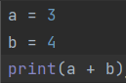
- Run the program and you see should 7.
- Go to Terminal and type in:
  - python -m pip install flake8 (this is to install flake8 from the terminal)
  - flake8 path/to/file/simple_example.py

- After running flake8 and you should get
- Now for pylint, go to Terminal and type in:
  - python -m pip install pylint (this is to install pylint from the terminal)
  - pylint path/to/file/simple_example.py

- After running pylint, you will get the following feedback and a score of -3.33
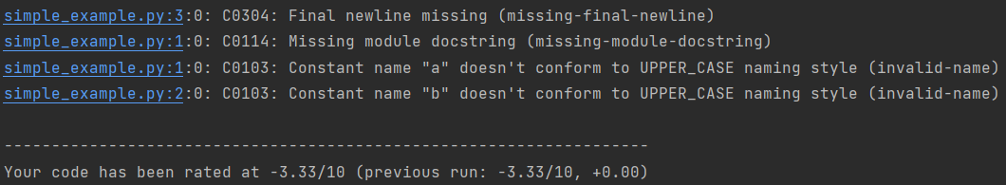
- The feedback from flake8 and C0304 from pylint are about the missing final newline. To resolve this, we just need to add a newline at the end:
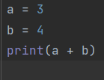
- Run Flake8 again and it no longer gives you any feedback.
For pylint, your score increases from -3.33 to 0 and the number of feedback has dropped from 4 to 3.
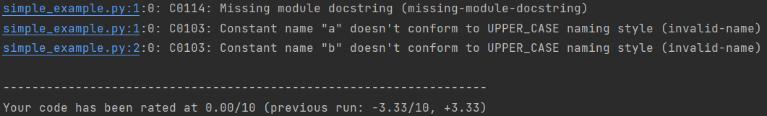
- Now to address C0114 (the missing module docstring) from pylint, we just need to add the docstring.
A Python docstring is a string used to document a Python module, class, function or method, so programmers can understand what it does without having to read the details of the implementation. We add in “””A simple example””” to the code as shown below:
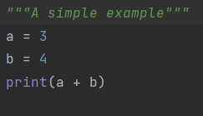
- Run pylint again and your score increases from 0 to 3.33.
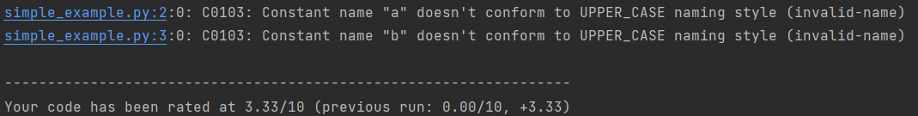
- And finally to address C0103 about the constant name not conforming to the naming style, we just need to change the constant name from lower to upper case as shown below:
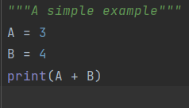
- Run pylint and now your score increases from 3.33 to 10. Perfect!
Note:
- If you get a low score it may not mean that your code is wrong. The score represents how good/bad your code is understandable by another programmer. You need to improve the code by considering the suggestions given in the report.
- Each message suggestion/point in the report will be given with a message format that consists of an ID and its meaning. Each ID starts with an alphabet and the rest will be numbered. Each alphabet denotes the type of message object.
- Some of the message objects are:
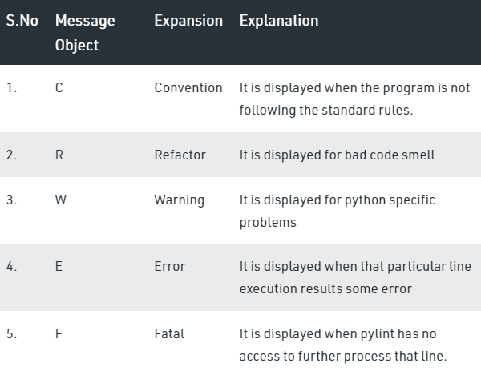
- If for some reasons, you would like pylint to ignore a certain feedback, you can disable it as shown:
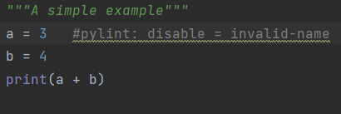
Initially, your feedback from pylint is shown below:
After adding #pylink: disable = invalid-name, pylink will ignore the feedback on line 2 about the invalid name and only show the feedback for line 3.
Task:
- Use the example_car.py file given.
- First use flake8 to improve the quality of the code in example_car.py until you no longer receive any feedback
- Then use the improved code and run pylint. Your score may still be low. Now improve the quality of the code based on the feedback from pylint until you can a score of 10.
(Hint: if for some reason, you think the feedback is not needed, you can use the disable feature mentioned earlier.)

- Use the example_math_py file given
  - Similar to task A, use flake8 to improve the quality of your code until you no longer receive any feedback
  - Use this improved code and run it with pylint. Improve on it until you get a score of 10.
  - What are the problems with the final improved code that are not picked up by both flake8 and pylint?

Additional Resources
- Ignoring Errors with Flake8
https://flake8.pycqa.org/en/3.0.2/user/ignoring-errors.html
- Pylint Tutorial – How to Write Clean Python https://www.youtube.com/watch?v=fFY5103p5-c
- flake8 in Python | Linters | PEP8 Standards https://www.youtube.com/watch?v=qUpfUenwUPA

